Static Analysis
Establish Settings Procedure

Revision
Version 2
2/3/26 8:27 AM

SME
Charles Wilson

Abstract
This document describes the procedure used to perform the establish settings activity described in the AVCDL ^{[1]} secondary document Static Analysis Report ^{[2]}.

Group / Owner
Security / Security Architect

Motivation
This document is motivated by the need to have early cybersecurity-related implementation feedback in the development of software for use within safety-critical, cyber-physical systems.
Note: Within the context of this document, the terms security and cybersecurity are used interchangeably. It is presumed that the term security is being used in reference to cybersecurity and not physical security.

License
This work was created by Torc Robotics and is licensed under the Creative Commons Attribution-Share Alike (CC BY-SA-4.0) License.
https://creativecommons.org/licenses/by/4.0/legalcode

Audience
The audience of this document is the cybersecurity practitioner who will be conducting cybersecurity-specific static analysis.

Completeness of Output
Since static analysis is an as-is analysis, it is critical to ensure that the information gathered is as accurate and complete as possible. As with any cybersecurity assessment, it is not the place of the cybersecurity SME to make assumptions on the part of engineering. All information should be sourced from and confirmed by the owner of the element under consideration.
When information is not available for either a given section of the template or parts thereof, this should be noted. Major omissions should be recorded in the cybersecurity risk register.

Disposition of Output
Once completed, the generated output should be managed in the organization’s document management system (DMS) as a document of record.

Entry Criteria
This document assumes that the reader understands the purpose of cybersecurity-relevant static analysis. Further, that the reader has read and understood the AVCDL Static Analysis Report ^{[2]} and Secure Settings Document ^{[3]} secondary documents.

Prerequisites – Development SME

Qualifications
It is required that the development SME is both a qualified and trained development SME with expertise in the element under consideration in the context of the tool under whose cybersecurity settings are being reviewed.
Note: The specific qualifications and training of development SMEs necessary to assert expertise in providing accurate information regarding the element under consideration is outside the scope of this document.
Note: The development group is responsible for determining and making available the appropriate SME for the analysis of the element under consideration.

Knowledge
It is required that the development SME have expertise in the element under consideration in the context of the tool under whose cybersecurity settings are being reviewed.

Prerequisites – Security SME

Qualifications
It is required that the security SME is both a qualified and trained security architect (shown above on title page as Owner) as defined by the NIST NCWF role SP-ARC-002 and detailed in section 12.7 Security Architect of the AVCDL primary document.

Knowledge
It is required that the cybersecurity SME understands the purpose of cybersecurity-relevant tool settings.

Background Information
It is required that the cybersecurity SME has read and understands the AVCDL Static Analysis Report, and Secure Settings Document secondary documents. Additionally, that the cybersecurity SME has taken training relevant to this activity.

Prerequisites – DevOps SME

Qualifications
It is required that the DevOps SME is both a qualified and trained DevOps SME with expertise in the build system used for the element under consideration in the context of the tool whose cybersecurity settings are being modified.
Note: The specific qualifications and training of DevOps SMEs necessary to assert expertise in providing accurate information regarding the build system used for the element under consideration is outside the scope of this document.
Note: The DevOps group is responsible for determining and making available the appropriate SME for the modifications to build system needed for the tool under consideration.

Knowledge
It is required that the DevOps SME have expertise in the build system used for the element under consideration in the context of the tool under whose cybersecurity settings need modification.

Prerequisites – Input Materials
It is required that the cybersecurity SME acquire all relevant documentation related to the tool under consideration necessary to complete the procedure.
It is required that the development group provide all relevant documentation related to the element under consideration necessary to complete the procedure.

Establish Settings Activity
The workflow diagram for the establish settings activity of the Static Analysis Report is shown below.
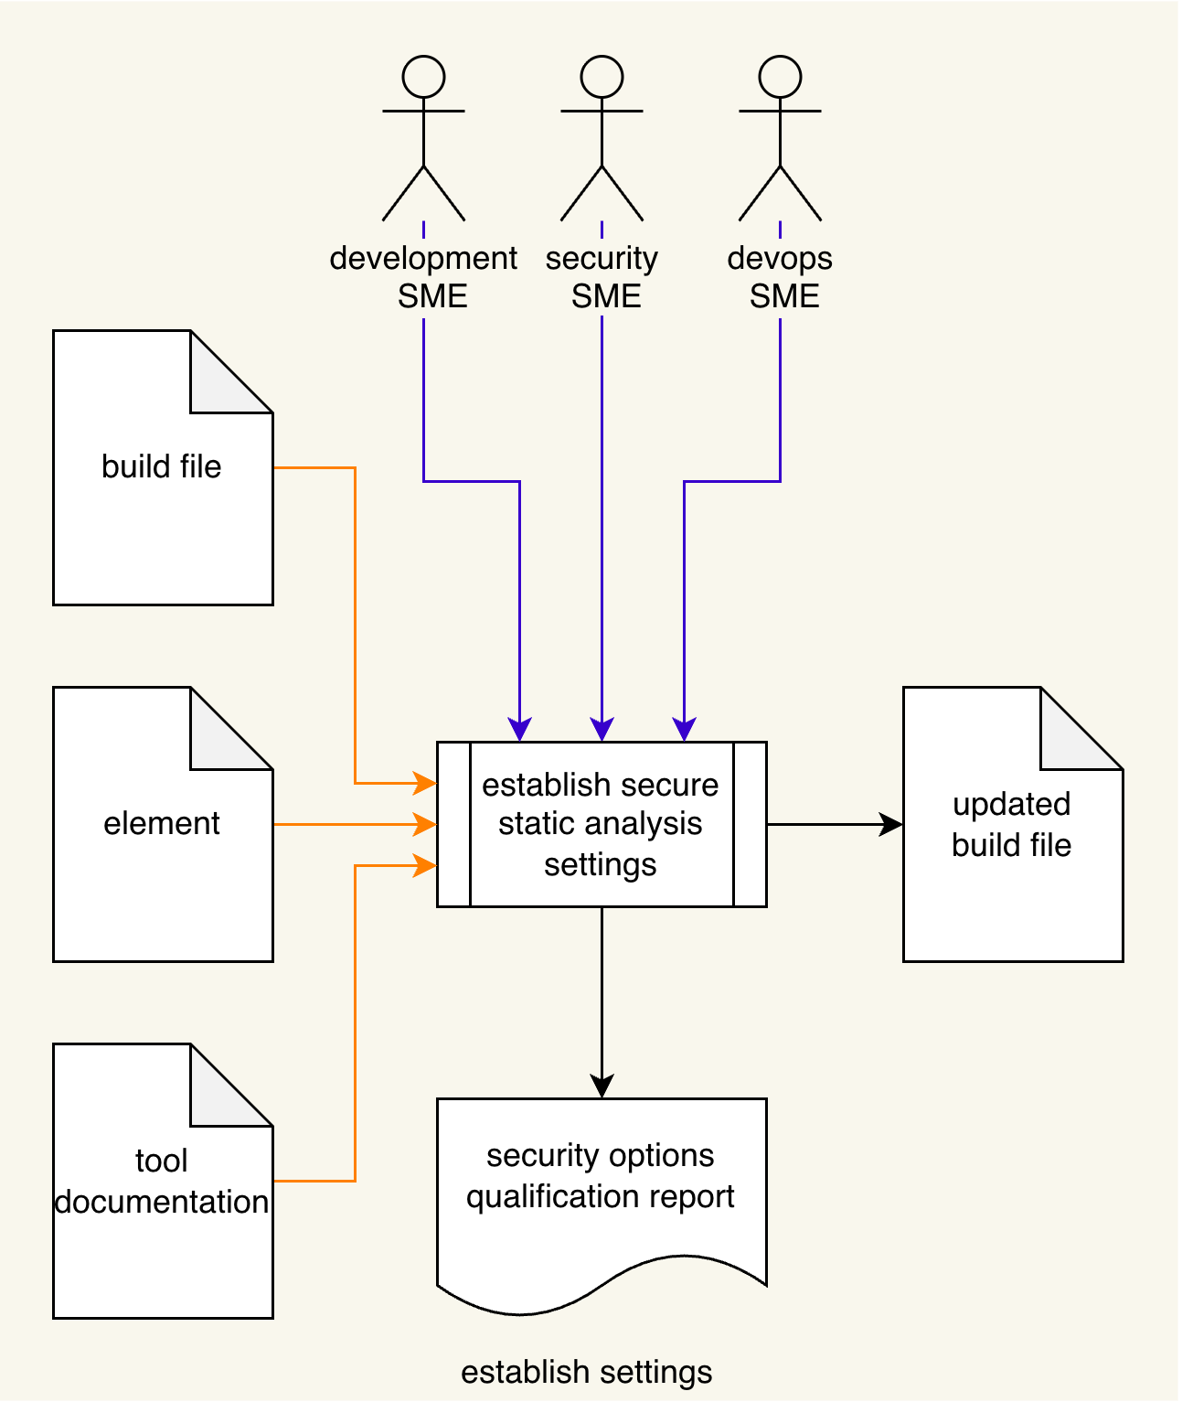
Using the Element under consideration, static analysis Tool Documentation, and Build File; the Development SME, Security SME, and DevOps SME will work together following the Secure Settings Document ^{[2]} process to determine what element aspects need to be considered and whether the element will require any annotation to restrict the scope of the analysis. An Updated Build File will be produced. A Security Options Qualifications Report is generated.
Note: The scope of the element may be as small as a single file, or as large as the entire project.

Settings Process Expanded
Consider the following diagram from the AVCDL Secure Settings Document secondary document.
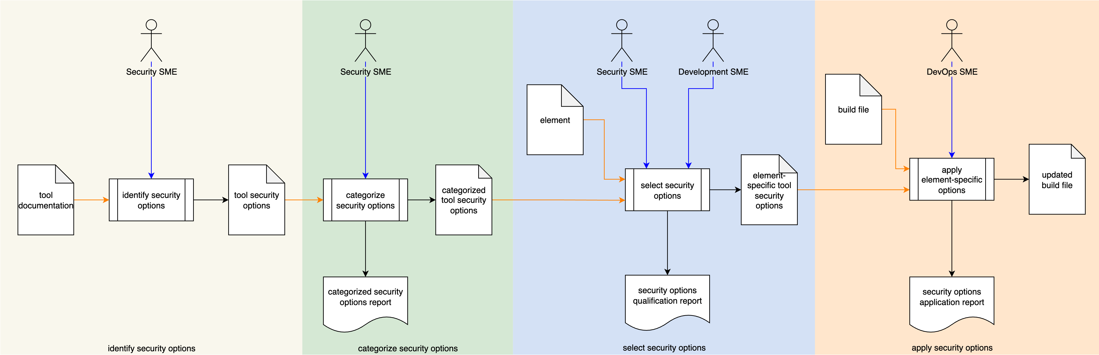
Here we can see that the static analysis establish settings activity is more accurately described as a full process in and of itself. It is expressed as a single activity because its steps are common to multiple activities within the AVCDL.

Methodology
The methodology to use in this activity is to follow the procedures laid out in the Secure Settings procedures ^{[4, 5, 6, 7]}.

Static Analysis Settings Templates
The static analysis settings may be documented using the AVCDL tool cybersecurity options template and AVCDL element-specific tool cybersecurity options template Microsoft Excel workbooks ^{[8, 9]}.
Note: These workbooks are covered in the AVCDL Secure Settings tertiary documents ^{[4, 5, 6]}.

Exit Criteria
This procedure is considered complete once the generated output has been entered into the organization’s DMS as a document of record.
Note: The processes and procedures for entering documents into the DMS, or the updating thereof, are outside the scope of this document.

References
- AVCDL (AVCDL primary document)
- Static Analysis Report (AVCDL secondary document)
- Secure Settings Document (AVCDL secondary document)
- Secure Settings – Identify Options Procedure (AVCDL tertiary document)
- Secure Settings – Categorize Options Procedure (AVCDL tertiary document)
- Secure Settings – Select Options Procedure (AVCDL tertiary document)
- Secure Settings – Apply Options Procedure (AVCDL tertiary document)
- AVCDL tool cybersecurity options template (AVCDL template)
- AVCDL element-specific tool cybersecurity options template (AVCDL template)

